K.G. MAHALAKSHMI


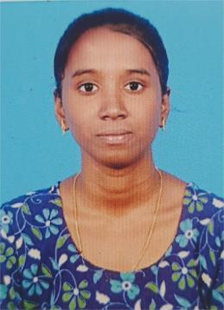
mahalakshmikathiravann@gmail.com
+91-6382903162
 https://www.linkedin.com/in/mahalakshmi-kathiravan-772326355/
 https://leetcode.com/u/mahalakshmi_kathiravan/

CAREER OBJECTIVE
Motivated and detail-oriented professional seeking a challenging position where I can utilize my skills and qualifications to contribute to organizational success and continue developing professionally.

EDUCATIONAL QUALIFICATION
Course | Name of the Institution | Year of  Passing | Percentage/CGPA
B.E. Mechatronics  Engineering | Kongu Engineering  College, Perundurai | 2027 | 8.77(till 4th Semester)
HSC | A.R.R.Matric.Hr.Sec.school,  Kumbakonam | 2023 | 86%
SSLC | A.R.R.Matric.Hr.Sec.school,  Kumbakonam | 2021 | Pass
SKILL SETS
C language, Java, Python, Solidworks and AutoCAD.

AREA OF INTERESTS
- Microcontroller Programming and Applications
- Web Development

PAPER PRESENTED
1.Nano Technology at Kongu engineering college
2.Development of Robotics at Coimbatore institute of technology
3.AI powered real time optimization at hindustan college of engineering

PROJECT PRESENTED
1.Automatic LPG gas booking system at Kongu engineering college
2.Tunnel booster fan monitoring and maintenance at Kongu engineering college

WORKSHOPS
- Attended a workshop on the topic of ROMO SUMO conducted by RBC club of Kongu engineering college
- Attended a workshop on the topic of ELECTROCAD workshop conducted by Mechatronics Engineering Association of Kongu engineering college

MEMBERSHIPS IN PROFESSIONAL BODIES
- Comparing Team Member, Mechatronics Association, KEC in 2024-2025
- Executive Member, Rotaract Club of KEC, Present

VALUE ADDED COURSE
- Completed a credit course on CLOUD COMPUTING In NPTEL
- Completed a credit course on DESIGN IMPLEMENTATION OF HUMAN SCIENCE AND INTERFACE in NPTEL

INPLANT TRAINING
- Undergone 10 days training in LETS GAME TECH, Coimbatore.
- Undergone 6 days training in WEBBOX SOFTWARE SOLUTION,kumbakonam

PERSONAL PROFILE
Father’s Name : Mr. Kathiravan Mahalingam
Mother’s Name : Mrs. Gomathi Kathiravan
Date of Birth & Age : 17-08-2006 & 19 years
Languages Known : English, Tamil, Hindi.

DECLARATION
I hereby declare that the information given above is true to the best of my knowledge.

Place : Perundurai
Date : 29/08/2025 (K.G.MAHALAKSHMI)

